**Team:** Data Science & Analytics

**Editor:** XIAOLU LI

**Data resource:** Fitness Trackers Products Ecommerce

**Introduction**

The Fitness Trackers Products Ecommerce dataset contains 610 samples with 11 variables. Variable description is in figure 1.

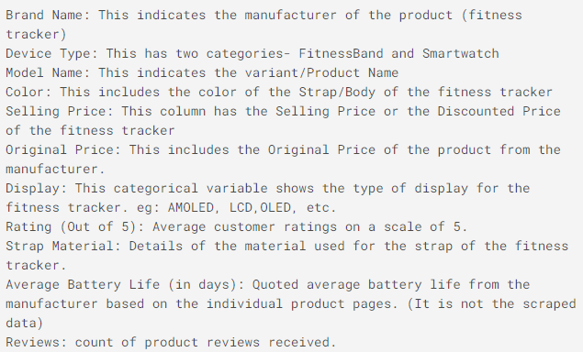

Figure 1. Data variable description

Because the variable ‘Review’ is not analysed, this variable is deleted. The dataset summary is in figure 2.

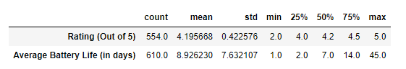

Figure 2. Dataset summary

**Data Visualization and Analysis**

**Market share of two device type**

Smart watch accounts for about 70% of the market shares, indicate that customers may prefer watch than bands. Also, it maybe because smart watches also provide other functions than doing exercise.

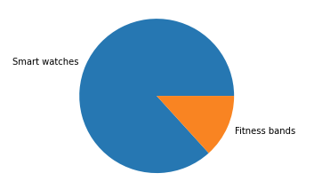

Figure 3. Market shares

**Relationships between each variable and rating scores**

* Brands with average rating scores

There are 25 Brands in the dataset, and the average rate score for each brand (out of 5) has been listed in the figure 3. According to the bar chart, Ptron has the lowest rate score, and Apple has the highest rate score.

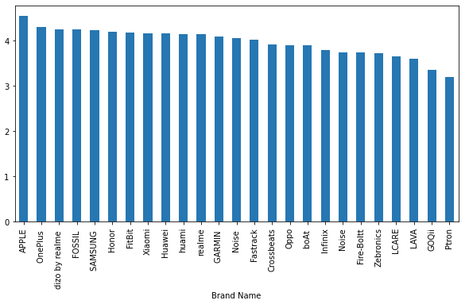

Figure 4. Brand Name with rating scores

* Device Type with average rating scores

There are two device types in dataset, Fitness Band and Smart watch. According to the visualization result, the rating scores for both categories are basically the same.

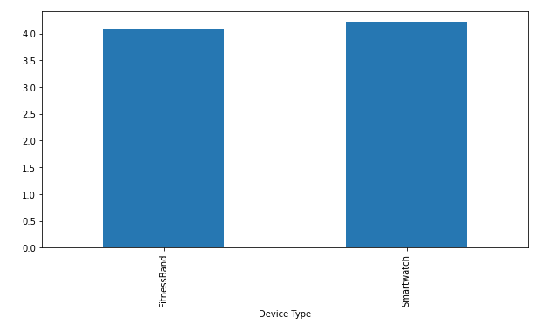

Figure 5. Device Type with rating scores

* Display with averaging rating scores

Similar to the results for the device type group, users have no particular preference for display. OLED retina display has a slight advantage in rating, and TFT-LCD display has a slight disadvantage.

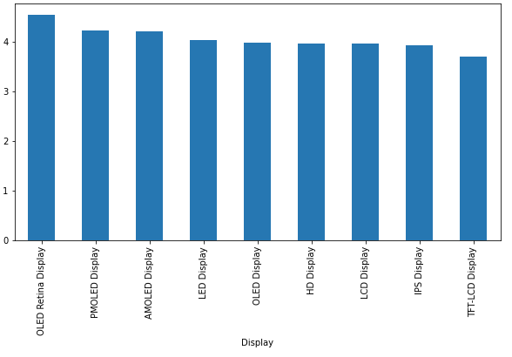

Figure 6. Display with rating scores

**Strap Material with rating groups**

There are 12 Strap materials have been used, and I analyse those rating scores to find out which is the most favourable one. In the first class (score between 4 and 5), Silicone is the best one, and Stainless Steel is the second.

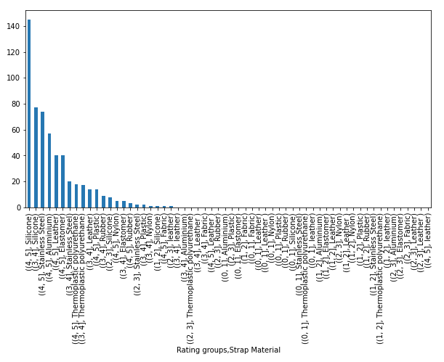

Figure 7. Strap Material with rating groups

**Brans Selling Price**

As a price reference, I analyse the price positioning of different brands. The price range of Apple, Garmin, Samsung, and OPPO are large, and other bands are concentrated below $6000. A price range with wider span can serve customers with more diverse needs, but also have higher cost requirements, such as more product lines.

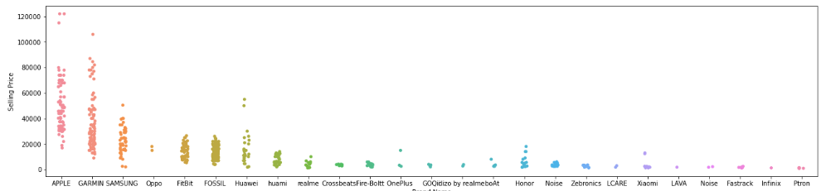

Figure 8. Banks price

**Recommendation**